Steps to be followed to take up the Software Testing SBA assessment in Ebox.

1. Login to Ebox(single sign-on)
2. Search for the assessment - **GTP Software Testing SBA**
3. Click on attempt in the below page.

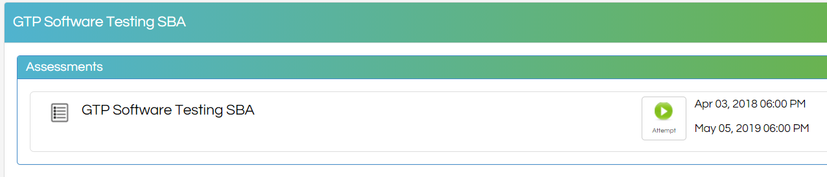

1. Click on continue in below page.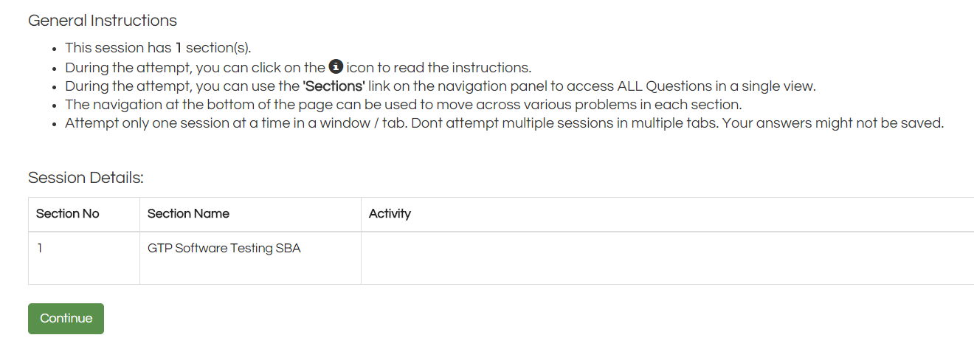
2. The Problem will be visible. Follow the instructions provided.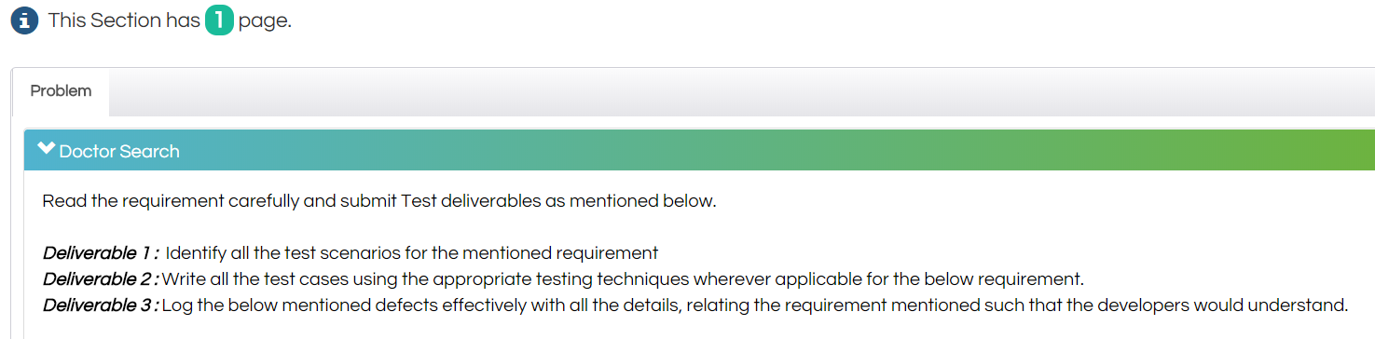
3. Open an excel from your system and enter the required deliverables as mentioned in the problem.
4. Click on Upload file.

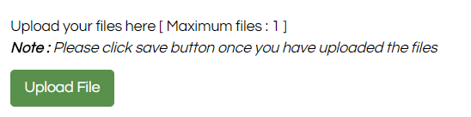

1. Click on choose file in the below screen.

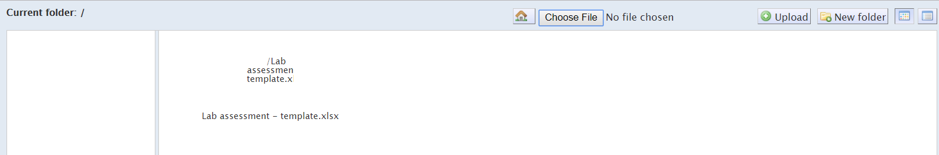

1. Select the saved excel with your deliverables from your system and click on Open.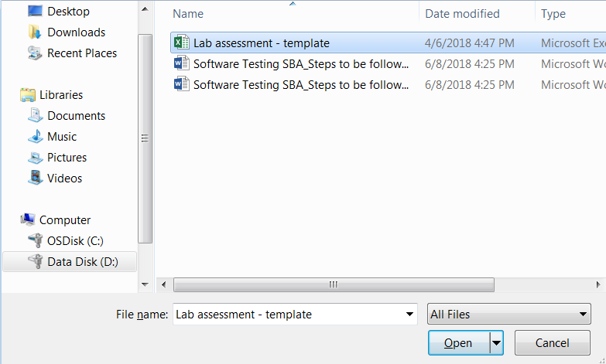
2. Click on Upload in the below page.

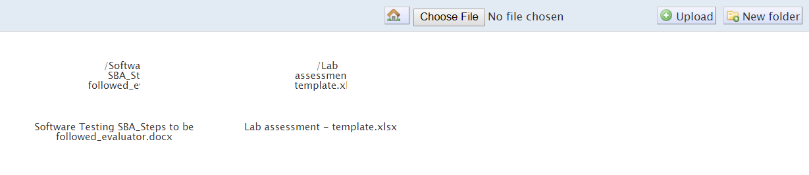

1. The intended file will be transferred. Click on the respective file and click on Select in the below page.

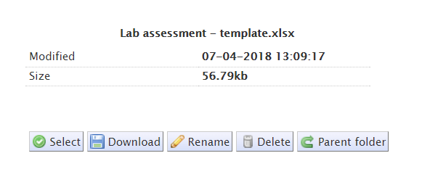

1. You will be navigated to the below page, where your uploaded file will be available, which can be downloaded or deleted using respective icons on the right. In case there are no changes you want to make to your file, click on Save.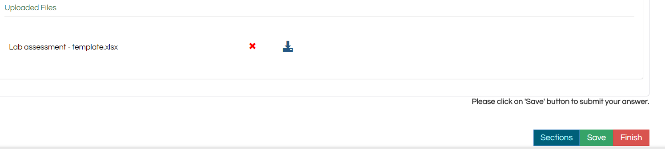
2. Click on Finish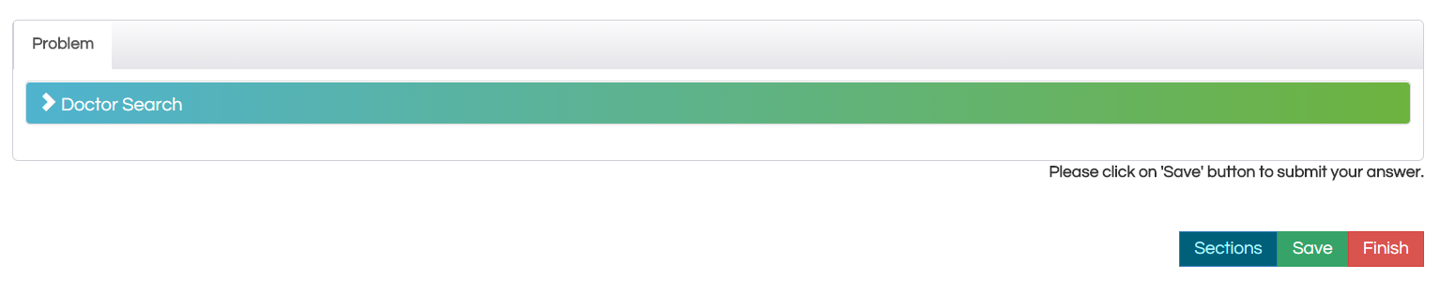
3. Click on Ok in the pop up. 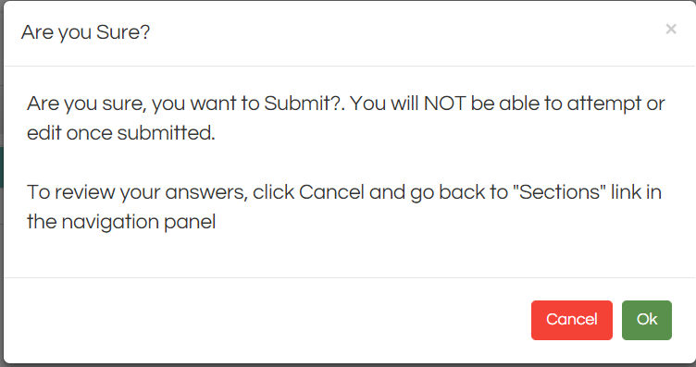
4. Please log off once you view the below screen.